COLLECTION DATE
 | 22nd | 23rd | 24th
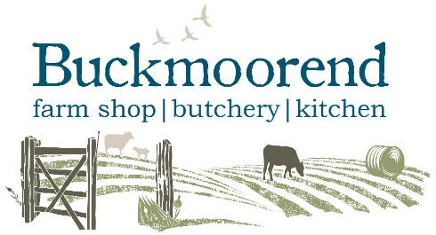
CHRISTMAS
ORDER FORM
FLACKWELL HEATH
23rd DECEMBER 4PM – 6PM

TEAM MEMBER: | ORDER DATE:
FIRST NAME: | SURNAME:
PHONE NO.: | EMAIL: |  | OPT OUT
TOTAL (approx. pending final weights): £ |  | DEPOSIT (non-refundable): £

MEAT CUT/SIZE | PRICE PER KG | ORDER (specify weight required) |  | PRICE
TURKEY 4.0 – 5.9KG | £18.98
TURKEY 6.0 – 6.9KG | £17.68
TURKEY 7.0 – 9.4KG | £17.04
TURKEY 9.5 – 11.0KG | £16.58
TURKEY CROWN 2.5 – 6.5KG  (legs included) | £31.62
SIRLOIN JOINT (B&R) | £39.50
RIB OF BEEF JOINT | £35.00
CHATEAUBRIAND | £76.00
PORK LOIN JOINT (B&R) | £14.65
SMOKED GAMMON | £16.00
UNSMOKED GAMMON | £16.00
SMOKED BACK BACON  (approx. 24 rashers/kg) | £20.00
UNSMOKED BACK BACON  (approx. 24 rashers/kg) | £20.00
SMOKED STREAKY BACON  (approx. 24 rashers/kg) | £20.00
UNSMOKED STREAKY BACON  (approx. 24 rashers/kg) | £20.00
PIGS IN BLANKETS  (approx. 15/kg) | £17.50 | GF
CHIPOLATAS  (approx. 20/kg) | £13.35 | GF
SIMPLY PORK SAUSAGES  (approx. 10/kg) | £13.35 | GF
CUMBERLAND  (approx. 10/kg) | £13.35 | GF
SAUSAGEMEAT | £12.70 | GF
DUCK (2.0 – 2.7kg) | £12.50
GOOSE (4.5kg – 6.0kg) | £22.00
OTHER

